WEEK 2 NET731 Practical’s

Week 2 simulates the role of an Azure Administrator it’s responsible for designing, deploying, securing, and monitoring a cloud infrastructure using Microsoft Azure.
Creating a virtual network named TechBridge-VNet using the resource group named CTU-20232041-RG. It is deployed in SA North region using Azure and provides communication boundaries for Azure resources.
It’s configured with address space of 10.0.0.0/16 because it provides large number of available IP addresses and allows logical separation.
The CTU-TechBridge-NSG needs to be create in the same resource group and region. It contains the inbound and outbound rules. Applies traffic filtering to help protect Azure resources.

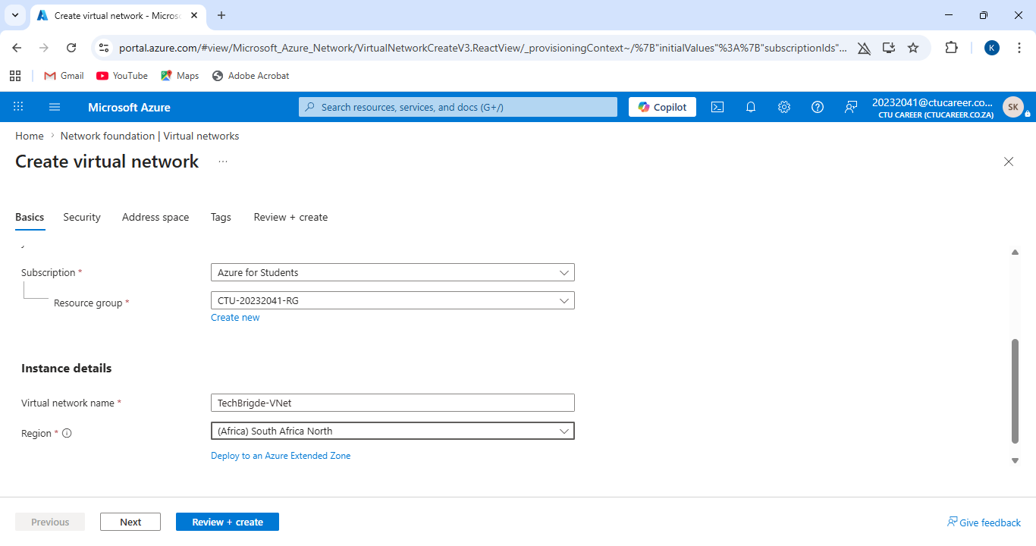

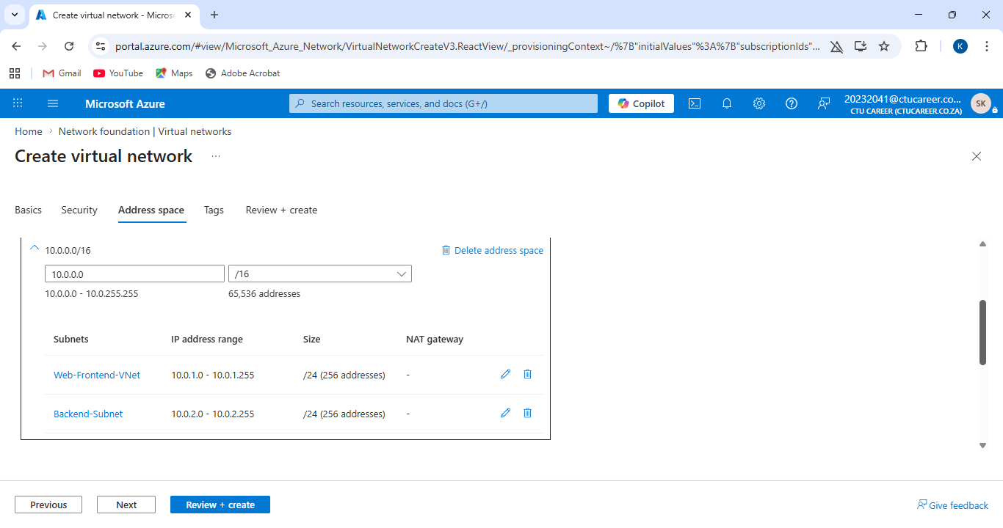

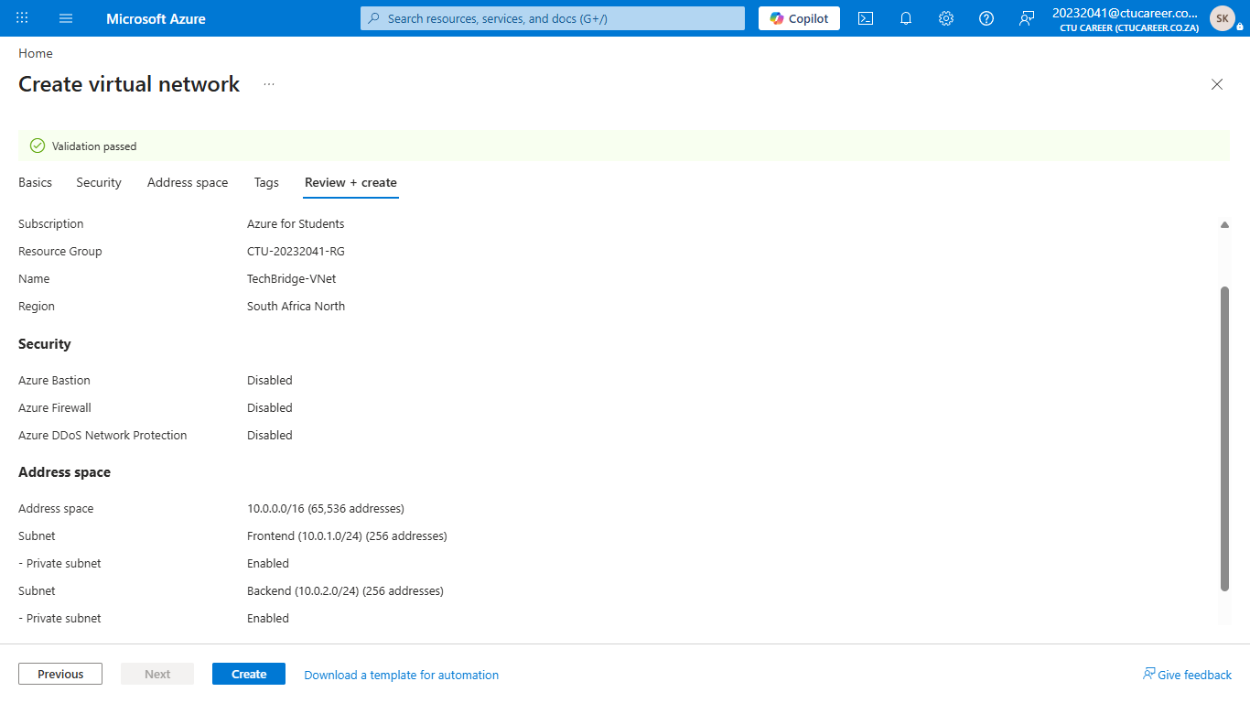

Here’s the proof that deployment failed.
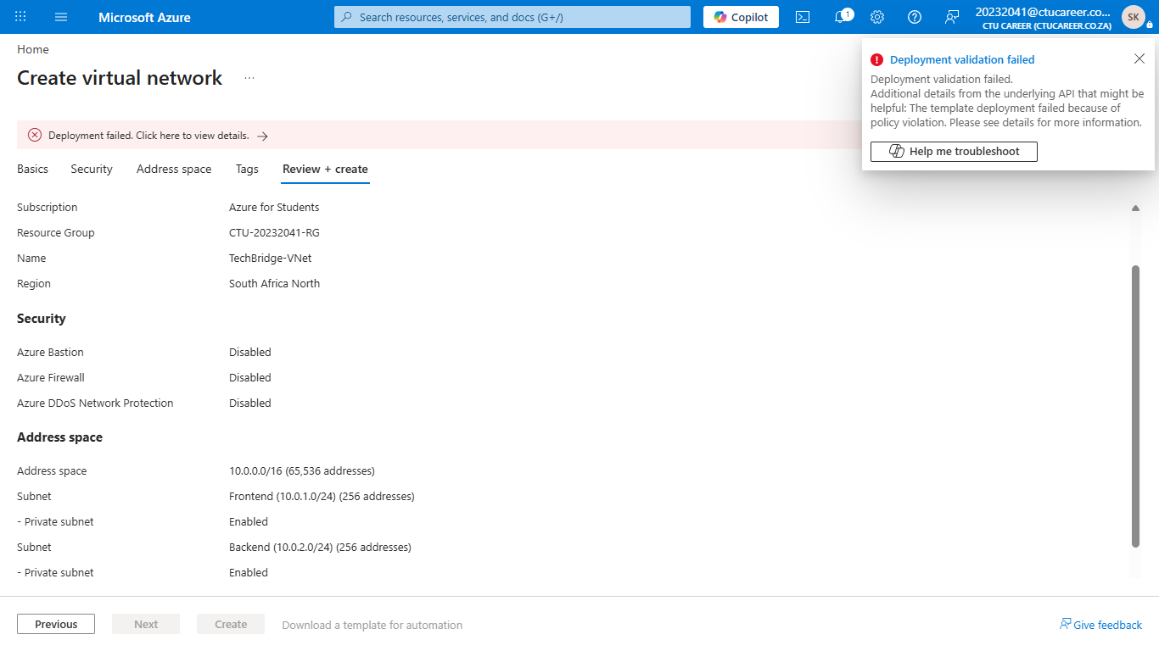

Didn’t allow me to create the NSG.
